UNIVERSIDAD MAYOR DE SAN ANDRES


PRACTICA 02

CARRERA: INFORMATICA
UNIVERSITARIA: MELANY BELEN YUJRA BAUTISTA
MATERIA: PROGRAMACION II
DOCENTE: JHONNY ROBERTO FELIPEZ ANDRADE
PARALELO: D
FECHA: 01 DE ABRIL DE 2026

LA PAZ - BOLIVIA
PRACTICA 1

EJERCICIO 1. MI PUNTO
DIAGRAMA UML
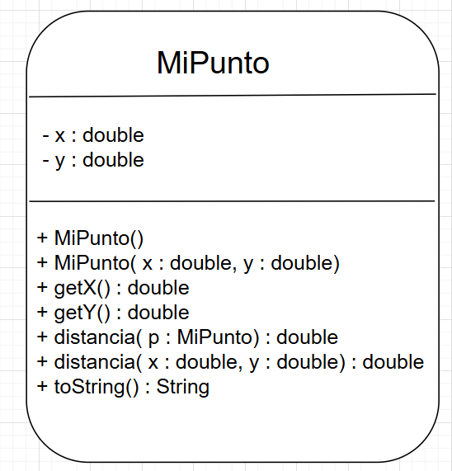
CODIGO EN JAVA
MiPunto.java
package Practica02.ejercicio1;
public class MiPunto {
private double x;
private double y;

public MiPunto() {
this.x = 0;
this.y = 0;
}

public MiPunto(double x, double y) {
this.x = x;
this.y = y;
}

public double getX() {
return x;
}

public double getY() {
return y;
}

public double distancia(MiPunto otro) {
double dx = this.x - otro.x;
double dy = this.y - otro.y;
return Math.sqrt(dx * dx + dy * dy);
}

public double distancia(double x, double y) {
double dx = this.x - x;
double dy = this.y - y;
return Math.sqrt(dx * dx + dy * dy);
}

@Override
public String toString() {
return "(" + x + ", " + y + ")";
}
}

Main.java
package Practica02.ejercicio1;
public class Main {
public static void main(String[] args) {

MiPunto p1 = new MiPunto();
MiPunto p2 = new MiPunto(10, 30.5);

System.out.println("Punto 1: " + p1);
System.out.println("Punto 2: " + p2);

double d1 = p1.distancia(p2);
System.out.println("Distancia entre puntos: " + d1);

double d2 = p1.distancia(10, 30.5);
System.out.println("Distancia usando coordenadas: " + d2);
}
}
EJECUCION
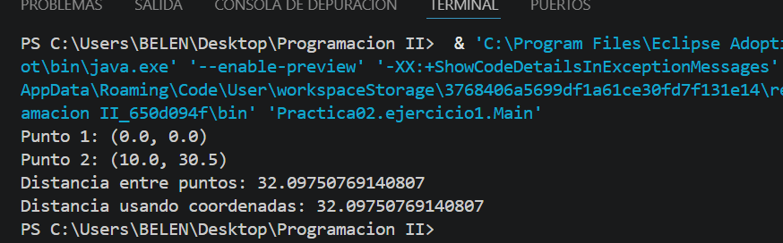
EJERCICIO 2: Algebra Vectorial
DIAGRAMA UML
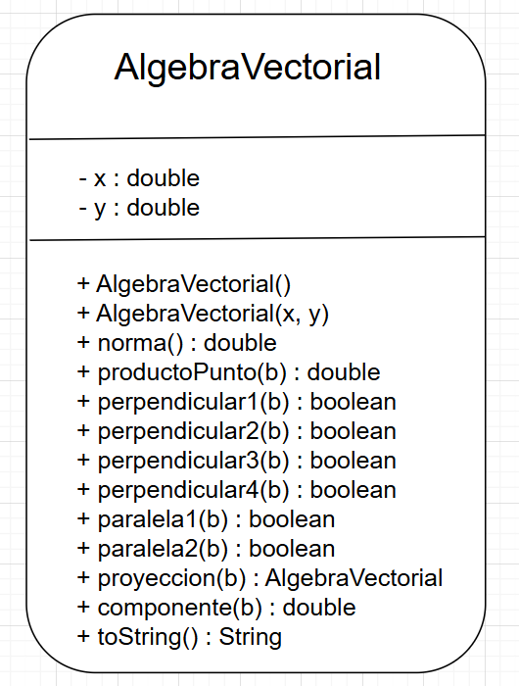
CODIGO EN JAVA
AlgebraVectorial.java
package Practica02.ejercicio2;
import static java.lang.Math.*;
public class AlgebraVectorial {
private double x;
private double y;
public AlgebraVectorial() {
this.x = 0;
this.y = 0;
}

public AlgebraVectorial(double x, double y) {
this.x = x;
this.y = y;
}
public double norma() {
return sqrt(x * x + y * y);
}
public double productoPunto(AlgebraVectorial b) {
return this.x * b.x + this.y * b.y;
}
public boolean perpendicular1(AlgebraVectorial b) {
AlgebraVectorial suma = new AlgebraVectorial(x + b.x, y + b.y);
AlgebraVectorial resta = new AlgebraVectorial(x - b.x, y - b.y);
return abs(suma.norma() - resta.norma()) < 1e-6;
}
public boolean perpendicular2(AlgebraVectorial b) {
AlgebraVectorial ab = new AlgebraVectorial(x - b.x, y - b.y);
AlgebraVectorial ba = new AlgebraVectorial(b.x - x, b.y - y);
return abs(ab.norma() - ba.norma()) < 1e-6;
}
public boolean perpendicular3(AlgebraVectorial b) {
return abs(productoPunto(b)) < 1e-6;
}
public boolean perpendicular4(AlgebraVectorial b) {
AlgebraVectorial suma = new AlgebraVectorial(x + b.x, y + b.y);
return abs(pow(suma.norma(), 2) - (pow(this.norma(), 2) + pow(b.norma(), 2))) < 1e-6;
}
public boolean paralela1(AlgebraVectorial b) {
if (b.x != 0) {
double r = this.x / b.x;
return abs(this.y - r * b.y) < 1e-6;
} else if (b.y != 0) {
double r = this.y / b.y;
return abs(this.x - r * b.x) < 1e-6;
}

return false;
}
public boolean paralela2(AlgebraVectorial b) {
return abs(this.x * b.y - this.y * b.x) < 1e-6;
}
public AlgebraVectorial proyeccion(AlgebraVectorial b) {
double normaB = b.norma();
if (normaB == 0) return new AlgebraVectorial(0, 0);

double escalar = productoPunto(b) / (normaB * normaB);
return new AlgebraVectorial(escalar * b.x, escalar * b.y);
}
public double componente(AlgebraVectorial b) {
double normaB = b.norma();
if (normaB == 0) return 0;

return productoPunto(b) / normaB;
}
@Override
public String toString() {
return "(" + x + ", " + y + ")";
}
}

Maln.java

package Practica02.ejercicio2;
public class Main {
public static void main(String[] args) {

AlgebraVectorial a = new AlgebraVectorial(2, 4);
AlgebraVectorial b = new AlgebraVectorial(1, 2);

System.out.println("Perpendicular (a·b=0): " + a.perpendicular3(b));
System.out.println("Paralela (a×b=0): " + a.paralela2(b));

System.out.println("Perpendicular1: " + a.perpendicular1(b));
System.out.println("Perpendicular2: " + a.perpendicular2(b));
System.out.println("Perpendicular4: " + a.perpendicular4(b));

System.out.println("Paralela1: " + a.paralela1(b));

AlgebraVectorial proj = a.proyeccion(b);
System.out.println("Proyección de a sobre b: " + proj);
double comp = a.componente(b);
System.out.println("Componente de a en b: " + comp);
}
}

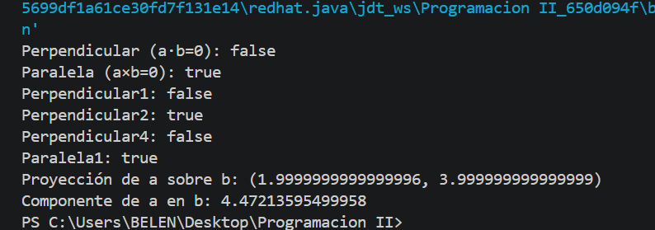
EJECUCION

EJERCICIO 3: Vector 3D
DIAGRAMA UML
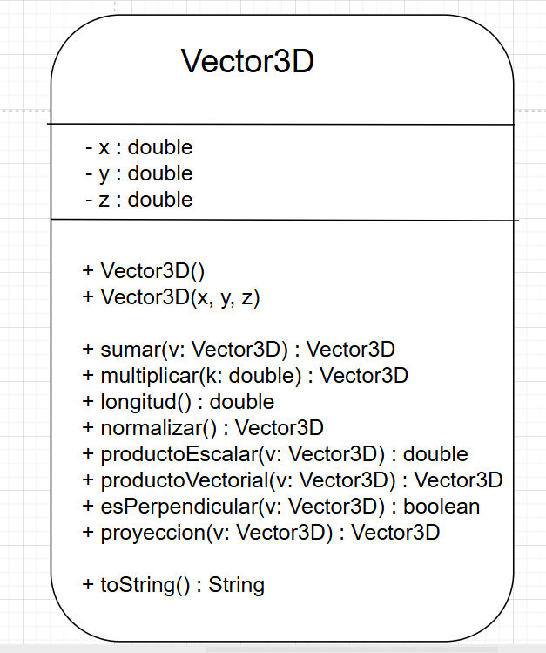
CODIGO EN JAVA
Vector3D.java
package Practica02.ejercicio3;
class Vector3D {
double x, y, z;

public Vector3D(double x, double y, double z) {
this.x = x;
this.y = y;
this.z = z;
}

public Vector3D sumar(Vector3D v) {
return new Vector3D(this.x + v.x, this.y + v.y, this.z + v.z);
}

public Vector3D multiplicar(double k) {
return new Vector3D(this.x * k, this.y * k, this.z * k);
}

public double longitud() {
return Math.sqrt(x*x + y*y + z*z);
}

public Vector3D normalizar() {
double len = longitud();
return new Vector3D(x/len, y/len, z/len);
}

public double productoEscalar(Vector3D v) {
return this.x*v.x + this.y*v.y + this.z*v.z;
}

public Vector3D productoVectorial(Vector3D v) {
double i = this.y*v.z - this.z*v.y;
double j = this.z*v.x - this.x*v.z;
double k = this.x*v.y - this.y*v.x;
return new Vector3D(i, j, k);
}

public boolean esPerpendicular(Vector3D v) {
return this.productoEscalar(v) == 0;
}

public Vector3D proyeccion(Vector3D v) {
double escalar = this.productoEscalar(v) / v.productoEscalar(v);
return v.multiplicar(escalar);
}

public String toString() {
return "(" + x + ", " + y + ", " + z + ")";
}
}

Main.java
package Practica02.ejercicio3;
public class Main {
public static void main(String[] args) {

Vector3D a = new Vector3D(1, 2, 3);
Vector3D b = new Vector3D(4, 5, 6);

System.out.println("Suma: " + a.sumar(b));
System.out.println("Escalar: " + a.multiplicar(2));
System.out.println("Longitud: " + a.longitud());
System.out.println("Normal: " + a.normalizar());
System.out.println("Producto escalar: " + a.productoEscalar(b));
System.out.println("Producto vectorial: " + a.productoVectorial(b));
System.out.println("Perpendicular: " + a.esPerpendicular(b));
System.out.println("Proyección de a sobre b: " + a.proyeccion(b));
}
}

COMPILACION
